**Identify objects.**

The only object of this Banking System would be the account.

**What are the associations between them?**

The account object would have attributes that would be able to differentiate it from the 3 different accounts; the banker, the customer, and the analyst. The Banker has the ability to create a new customer for the banking system and represents the functions of the banking system, the Customer utilizes the functions of the banking system such as the deposit and withdraw functions, and the analyst pulls data from the database that the banker and customer request.

**What is their multiplicity?**

There will be an undefined number of accounts, but there will be at least two accounts.. There will be at least one banker, at least one analyst, and there will be an undefined number of customers.

**What are the attributes of the objects?**

Attributes of the account include name, dob, social security number, account balance, email, username, password, account type.

**What operations are defined on the objects?**

Attributes of the banker include the ability to register customers, transfer customer funds, send deadline notifications, and the ability to check ledger and balances. Attributes of the customer include the ability to deposit, withdraw, check balance, check ledger, pay bill, and transfer funds. Attributes of the analyst include the ability to send customer balance and ledger history to the customer or banker upon query.

**Create system class diagram**

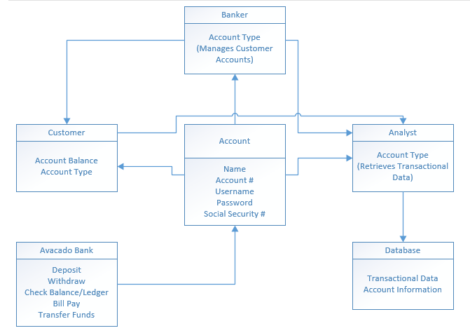

**Specify your system database tables (data attributes and their types) and**

**relationship between them (Primary Keys and Foreign Keys)**

The first table would have 3 data types which include INT, DATE, and VARCHAR.

* INT Attributes: social security number, account number, account balance
* DATE Attributes: date of birth
* VARCHAR Attributes: first name, last name, email address, username, password, account type
* The primary key would be the account number.

The second table would have 2 data types which include INT and DATE.

* INT Attributes: transaction number, transaction amount, and account number
* DATE Attributes: transaction date
* The primary key is the transaction number.

**8. Specify the type of database management system (MySQL, MS-SQL server, Oracle,**

**etc.) you will use in your project**

The database management system that will be used in the project will be MySQL.